- inux Commands
1.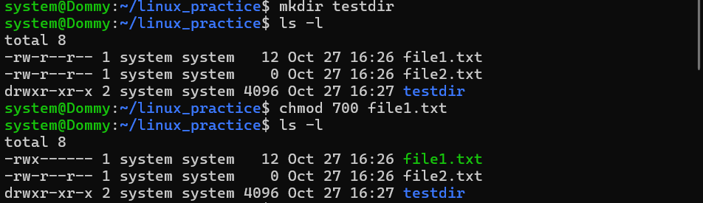
2.
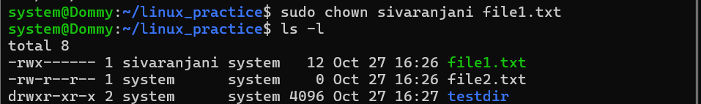
3.
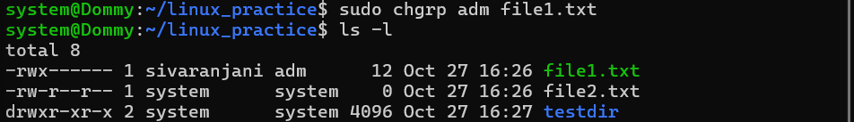
4.
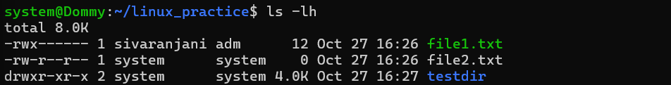
5.
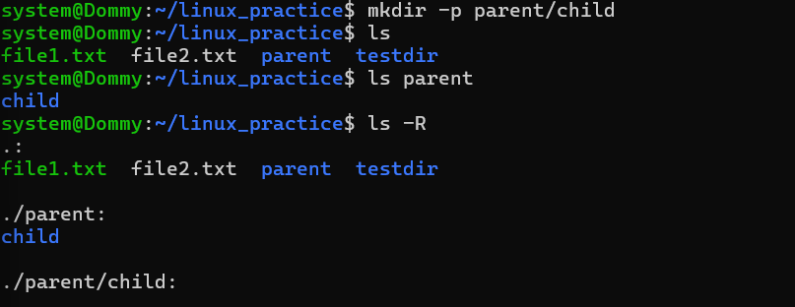
6.
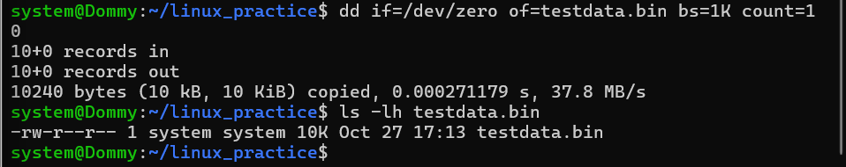
Explanation:
- if=/dev/zero: Input source containing zero bytes.
- of=testdata.bin: Output file.
- bs=1K: Block size of 1 KB.
- count=10: Write 10 blocks.
7.
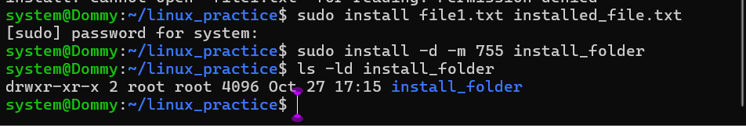
8.
Creating a hardlink with same inode number
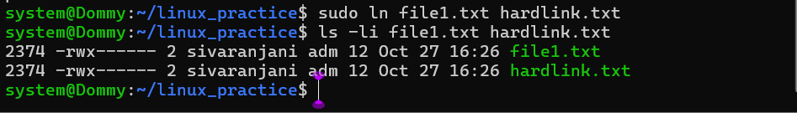
9.
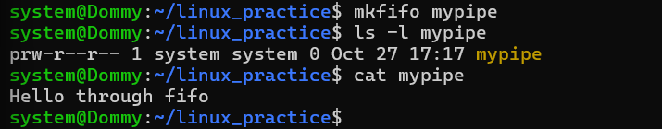
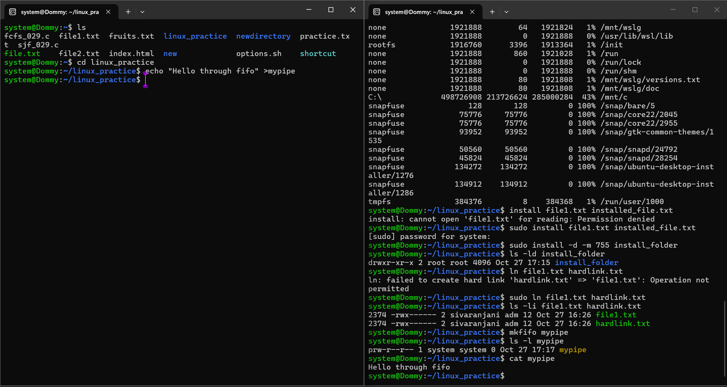
10.
